Case 6-Afr-Ghana-Komaland-Male Bearded Figure-Burial Mark- 1200-1600 CE

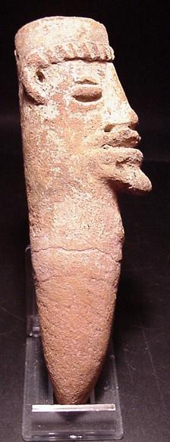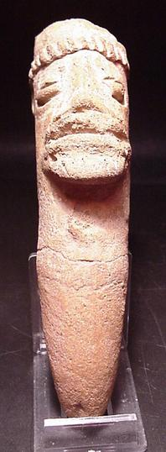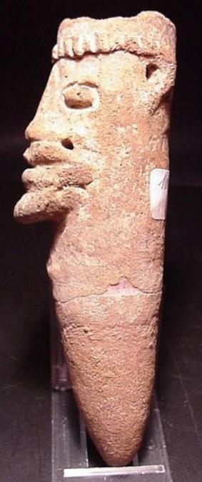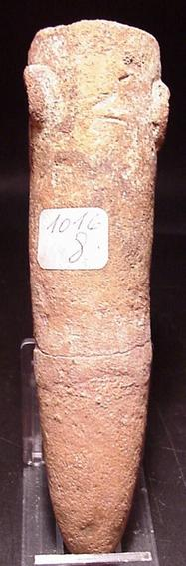

Case No.:
Accession Number:
Formal Label:
Display Description:
Conically shaped terracotta sculptures, such as this superb example, were used to mark burial mounds
Komaland is located south of the Burkina Faso border in Northern Ghana, in the valleys between Sisilli and the Kulpawan rivers. The people of Komaland are mainly farmers, growing corn, millet, onions, tomatoes, and various types of nuts. Until 1985 very little was known about this mysterious culture. During the previous 20 years farmers hahad found terracottas in the ground, but knew nothing of their history. Their value was soon recognized by scholars. In March and April of 1985 a permit was issued to excavate the Komaland site. Since then more information about this unique culture has filtered out. The present-day village is built around and on numerous archaeological sites. Many of the pieces found today and in the past 30 years were found in burial mounds; the mounds contained terracotta figures, domestic pottery, milling stones, pottery discs, iron ornaments, copper ornaments, iron implements and stone axes.

LC Classification:
Date or Time Horizon:
Geographical Area:
Map:
GPS Coordinates:
Cultural Affiliation:
Medium:
Dimensions: length : 15.3 cm ( 6.02 inches) width : 4 cm ( 1.57 inches)
Weight:
Provenance: from an old collection.
Condition: original, BROKEN AND RESTORED (see photos)

Discussion:
References

